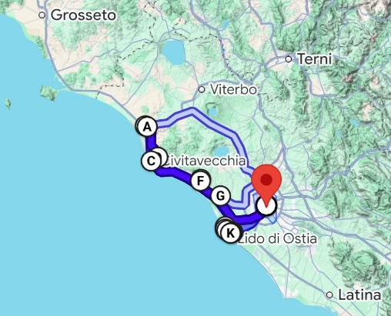
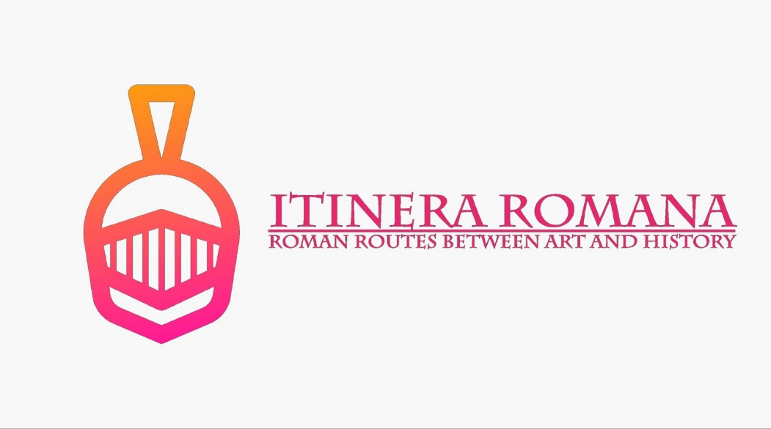

9° Percorso – “Iter Traiano”

Where: Tarquinia / Civitavecchia
Cerveteri / Ostia


How: Car

Time: 4:00 Hours
Total Trip Time: From 9 up to 10 Hours
Departure: San Giovanni (Metro A)
Arrival: San Giovanni (Metro A)

VS. 2 | English Version | Tickets | No Booking
VS. 2 | English Version | Tickets | No Booking
VS. 2 | English Version | Tickets | No Booking
VS. 2 | English Version | Tickets | No Booking
VS. 2 | English Version | Tickets | No Booking
VS. 2 | English Version | Tickets | No Booking

- Necropoli dei Monterozzi
- Museo Archeologico Nazionale di Tarquinia
- Museo Archeologico Nazionale di Civitavecchia
- Terme Taurine o di Traiano
- Necropoli della Banditaccia
- Museo archeologico nazionale Cerite
- Osteria dell'Elefante, Via di Torrimpietra, 247, 00054 Torrimpietra RM

VS. 2 | English Version | Tickets | No Booking
VS. 2 | English Version | Tickets | No Booking
VS. 2 | English Version | Tickets | No Booking
VS. 2 | English Version | Tickets NO | No Booking
VS. 2 | English Version | Tickets info | No Booking
VS. 2 | English Version | Tickets | No Booking
- Museo delle navi romane
- Area Archeologica dei Porti di Claudio e di Traiano
- Necropoli di Porto
- Museo di Ostia antica
- Parco Archeologico di Ostia Antica
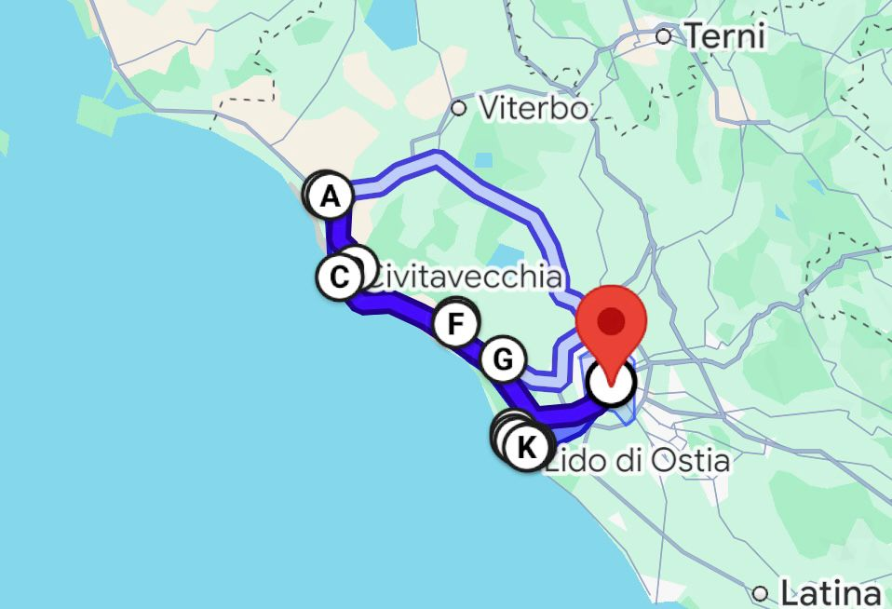
- Castello di Giulio II
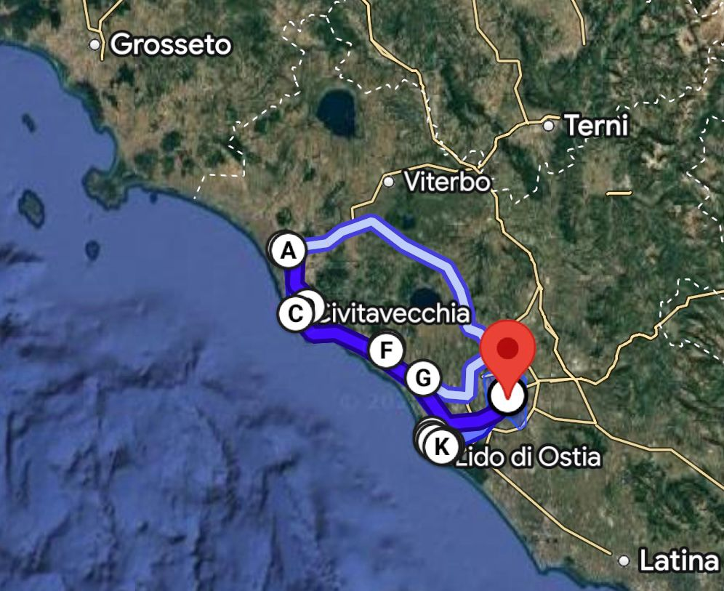

🔮 Necropoli dei Monterozzi di Tarquinia
🌿 Etruscan Necropolises of Cerveteri and Tarquinia 🌿
These two expansive Etruscan cemeteries showcase diverse burial customs spanning from the 9th to the 1st century BC, bearing witness to the remarkable achievements of Etruscan civilisation—the earliest urban culture to flourish in the northern Mediterranean. Some tombs are monumental, carved from rock and topped by impressive burial mounds (tumuli), while others feature exquisite wall carvings and vividly painted frescoes.
The necropolis near Cerveteri, known as Banditaccia, comprises thousands of tombs organised along streets, squares, and neighbourhoods, echoing a city’s layout. It presents diverse tomb types—trenches carved directly into the rock, tumuli, and tombs shaped like houses or huts complete with structural details, offering unique insights into Etruscan residential architecture.
Tarquinia’s necropolis, known as Monterozzi, contains around 6,000 rock-cut tombs and is celebrated particularly for its 200 painted tombs, some dating as far back as the 7th century BC.

Monterozzi Necropolis in Tarquinia 🏺🌺
Stretching approximately 6 kilometres along a ridge parallel to the Tyrrhenian coast lies the Monterozzi hill, home to Tarquinia’s primary necropolis. More than 6,000 tombs have been identified here, most consisting of underground chambers topped originally by mounds—once numbering over 600, though now largely flattened by agricultural activity. This gave the hill its evocative name, “Monterozzi,” derived from these mounds.
Massimo Pallottino famously described the exceptional painted tombs here as “the first chapter in the history of Italian painting.” While painted tombs appear elsewhere in Etruria, only at Tarquinia do we find such an extensive and continuous tradition, lasting from the 7th to the 2nd century BC.
Today, visitors can admire 22 tombs accessible to the public, featuring vivid scenes of banquets, dancers, musicians, athletes, hunting scenes, fishing expeditions, mythological creatures, and even demonic figures depicting the Etruscan view of the afterlife. These paintings offer an unparalleled insight into Etruscan society, surpassing even Roman representations in detail and vibrancy.

Visiting the Tombs: An Underground World 🕯️🖌️
Visitors enter each tomb via a staircase descending below ground level, where modern thermal glass doors ensure paintings remain visible while preserving optimal temperature and humidity conditions.
Notable tombs open to visitors include:
- Tomb of the Bacchants
- Bartoccini Tomb
- Tomb of the Deer Hunt
- Tomb of Hunting and Fishing
- Tomb of the Hunting Pavilion
- Tomb of the Blue Demons
- Tomb of the Lionesses
- Tomb of the Leopards
- Tomb of the Lotus Flower
- Tomb of the Whipping
- Tomb of the Jugglers
- Tomb of the Warrior
As of August 2023, the site’s accessibility has been enhanced with virtual tours accessed through QR codes along the route. Visitors can explore the tombs virtually via their smartphones, examining fresco details not clearly visible from outside.
This interactive experience appeals especially to younger visitors, combining education with a playful exploration of Etruscan culture. The virtual tour is continually improving, with further enhancements planned from September 2023, making it more accessible both onsite and from home.

Painted Tombs: Life and Death in Colour 🎨⚱️
The painted tombs of Tarquinia document nearly the entire life of the city, from the 7th to the 3rd century BC, reflecting evolving beliefs about the afterlife. Early tombs feature limited decorative motifs, while later chambers are richly adorned, depicting lavish banquets, musicians, dancers, athletic competitions, hunting scenes, and ceremonies honouring the deceased.
From the 5th century BC onward, Greek mythological motifs appear, marking a shift toward a more complex view of the afterlife, filled with mythological beings and monstrous demons.
With Tarquinia’s incorporation into Roman political control, the tradition of tomb painting gradually declined, virtually ceasing by the late 3rd century BC.

Conservation and Accessibility 🌐🔍
The preservation of these delicate frescoes, now a UNESCO World Heritage Site since 2004, remains a top priority. To balance protection with public accessibility, the Archaeological Superintendency has installed transparent, temperature-controlled barriers at tomb entrances. These safeguard the fragile paintings from environmental variations, especially humidity and CO2 levels caused by visitor presence.
Though some tombs must remain closed for conservation, ongoing efforts ensure that the most significant ones remain accessible to the public, offering glimpses of a vibrant culture, rich in beauty and history.
Monterozzi Necropolis of Tarquinia – where ancient beauty and mystery meet, telling the vibrant story of an extraordinary civilisation! 🌺🏺✨

🏛️ Cerveteri and Tarquinia Archaeological Park – National Archaeological Museum of Tarquinia
Welcome to the splendid Palazzo Vitelleschi, home to the National Archaeological Museum of Tarquinia—a treasure chest brimming with masterpieces from the intriguing Etruscan civilisation. A journey through three floors packed with history, art, and a generous sprinkle of archaeological glamour! ✨🏺🗝️

📍 GROUND FLOOR – The aristocratic side of the afterlife 🛏️
- 🗿 Sarcophagi from Tarquinia’s elite (4th century BC)
Discover the luxurious tombs of Tarquinia’s aristocracy, with stunning stone sarcophagi carved from Greek marble. In Room 10, you'll find some truly splendid pieces belonging to the city’s most distinguished families—so impressive, you'd almost want one yourself (though not anytime soon, we hope)! 😉

🎨 FIRST FLOOR – Gods, horses, and ancient crafts 🐴⚡
- 🐎 Winged Horses ('Cavalli Alati'): The absolute stars of the museum! These majestic terracotta horses once adorned the temple of 'Ara della Regina'—think Ferrari, but Etruscan! 🏇💨
- ⚔️ Mithras Tauroctonus (2nd-3rd century AD): A dramatic sculpture of the god Mithras slaying a bull. Discovered in 2015, this thrilling scene was the Roman version of binge-watching a Netflix epic drama! 🍿🎬
- 🏺 Pottery & precious trinkets:
  - Etruscan-Corinthian pottery—think 'Greek chic' at affordable prices!
  - Stunning jewellery with gold granulation—sparkling proof that fashion never goes out of style! 💍✨
  - Bronze and gold coins—proof that Etruscans knew a thing or two about bling and budget management. 💰

🌅 SECOND FLOOR – Frescoes & Views: Art with a View 🖼️🌳
- 🖌️ Frescoed Tombs (The virtual Etruscan afterlife!): Four painted tombs, delicately detached and reconstructed, await you here. The Tomb of the Triclinium offers banquets and music—quite literally an eternal party. 🎉
- 🎖️ Hall of Arms ('Salone delle Armi'): Discover weapons and treasures unearthed by diligent archaeologists from the universities of Milan and Perugia. If Indiana Jones visited Tarquinia, he'd definitely hang out here. 🗡️🕵️‍♂️

🛠️ DETACHMENT TECHNIQUE – 'Strappo' explained 📐
- During the 1950s, the frescoes in delicate conditions were carefully detached using the famous Italian 'strappo' technique—saving these masterpieces so you can Instagram them today! 📸🙌

⚰️ FAMOUS TOMBS – Instagrammable afterlife moments
- 🍷 Tomb of the Triclinium:
  - "The tomb of joy and feasts!"—complete with dining, dancing, music, and even pets under the table (a rooster, a cat, and a partridge—ancient VIPs, obviously!) 🐓😺
- 🚢 Tomb of the Ship:
  - Unique seafaring frescoes with ships, a lively party, and a bit of marine sightseeing—an Etruscan luxury cruise, anyone? 🛳️🍹
- 🏅 Tomb of the Olympic Games:
  - Action-packed with ancient sports (running, boxing, chariot races), this tomb was the ESPN of the ancient world—Olympics, Etruscan style! 🏇🥊🥇
- 🏇 Tomb of the Bigas:
  - Elegant and luxurious, with spectators comfortably seated watching chariot races and games—a posh day at the ancient races! 🎩🥂

🌟 WHY VISIT? – Your ticket to the Etruscan 'dolce vita' 🍷🏛️
- The museum perfectly blends archaeology, art, and history with just the right dose of humour.
- Exceptional collections that showcase ancient life in style.
Grab your sandals, channel your inner Indiana Jones, and head over to Tarquinia's National Archaeological Museum. Ancient history has never been so stylish! 🕶️👒🌿

🏛️ National Archaeological Museum of Civitavecchia
📍 Ground Floor
Housed in a charming 18th-century building commissioned by Pope Clement XIII (yep, even Popes loved a stylish pad 🏰), just steps from Fort Michelangelo, the National Archaeological Museum of Civitavecchia is an essential stop on your cultural itinerary. Compact yet filled to the brim with treasures, it offers a delightful journey through history, from the Etruscans to Ancient Romans—without overwhelming your Instagram feed 📸.
🔹 The ground floor kicks off the tour with some star attractions: don’t miss the stunning 2-metre-tall marble statue of Apollo (1st century AD), probably catching a bit of sun before it was unearthed from Villa Simonetti in Santa Marinella—once the summer home of the famed Roman jurist, Ulpian.
🔹 Nearby is another showstopper, a Roman copy of Phidias' Athena Parthenos, looking resplendent thanks to its contemporary ‘Blue Klein’ background. A perfect spot for a museum-selfie! 📷✨
You’ll also spot some intriguing portraits, including one of a young Marcus Aurelius—before he got philosophical!

⚱️ First Floor
Heading upstairs, you’ll find a treasure trove of artifacts showcasing daily life along the coast and inland at Santa Marinella, Allumiere, and Tolfa.
Key pieces include:
- 🥂 A beautiful 7th-century BC chalice decorated with intricate patterns.
- 🌺 An exquisite Egyptian-inspired balsamarium (6th century BC), depicting a woman gracefully kneeling before another. Ancient Egypt meets Etruria—fancy!
- ⚱️ A selection of fine Etruscan bucchero pottery, that elegant, glossy black ceramic which screams sophistication—think of it as the Etruscan designer crockery of its day!
Don’t skip the intriguing display of votive offerings (ex votos)—terracotta replicas of body parts offered to the gods (talk about practical healthcare 🏺🙌!).

🛡️ Extra Special Exhibitions
- 📜 Coins & Inscriptions: A captivating selection of inscriptions, Roman bronze coins, and gleaming imperial gold coins unearthed from the nearby Roman colony of Gravisca (181 BC). Romans were always serious about their cash! 💰
- 💎 Gold Jewellery: Marvel at delicate necklaces and earrings made using intricate granulation techniques—luxury Etruscan style!
- 🛡️ Bronze Polena: Check out a unique bronze prow figurehead (polena), a striking female bust donated by Prince D'Ardia. Roman elegance meets maritime charm!

🏺 Special Rooms and Displays
- Hall of Arms: Offers more intriguing discoveries from extensive excavations at Tarquinia and Gravisca—think swords, armour, and more! ⚔️
- Salone delle Feste (Hall of Banquets): Coins, jewellery, and impressive tableware that would put any modern dinner party to shame. Cheers to history! 🥂

🎨 Wall Paintings & Detached Frescoes
Four breathtaking tombs have been reconstructed on the second floor, allowing you to walk straight into Etruscan banquets, chariot races gone wild, and athletic games:
- 🏇 Tomb of the Bigas (490-480 BC): Packed with horse-racing drama and chariot crashes—Formula One, ancient style!
- 🏅 Tomb of the Olympic Games (530-520 BC): Athletic competitions, banquets, and a cheeky fake door—a must-see for any sports (or feasting) fan!
- 🛳️ Tomb of the Ship (mid-5th century BC): Unique maritime scenes with cargo ships and sailors busy at work.
- 🍷 Tomb of the Triclinium (470-440 BC): Lavish banquet scenes with musicians, dancers, and a cat probably plotting to steal snacks—because some things never change!
The paintings were carefully detached in the '50s using the Italian ‘strappo’ technique to preserve their vivid beauty.

🐎 The Winged Horses (490-480 BC)
Last but certainly not least, the museum’s iconic symbol: the stunning relief sculpture of two winged horses pulling a biga (chariot). Once adorning the grand ‘Ara della Regina’ temple, this vibrant terracotta masterpiece is truly Insta-worthy 📸🦄✨.

🏺 Why visit?
Smaller it may be, but this museum packs a powerful punch of culture, beauty, and quirky charm. A hidden gem that tells the rich history of Civitavecchia—from Etruscan splendour to Roman power moves.

Taurine Baths (Trajan's Baths) – Civitavecchia
🌊🏛️ The Taurine Baths – Rome's Ancient Wellness Retreat ♨️✨
Hidden among the hills overlooking the Tyrrhenian coast near Civitavecchia, the Taurine Baths—often known as the Baths of Trajan—are among the most impressive Roman thermal complexes in central Italy. Renowned since antiquity for their therapeutic waters, they offer a fascinating combination of archaeology, history and nature.

👑🏛️ From Etruscans to Emperors
Although the thermal springs were already known in Etruscan times, the monumental complex visible today was largely developed under Emperor Trajan at the beginning of the 2nd century AD.
Favoured by emperors, senators and wealthy citizens, the baths became an important destination for leisure, health and social life, attracting visitors from across the Roman world.

♨️✨ A Masterpiece of Roman Engineering
The complex included all the essential elements of a Roman spa:
• 🔥 Caldarium – The hot bathing rooms.
• 🌡️ Tepidarium – Warm intermediate chambers.
• ❄️ Frigidarium – Cold-water pools for refreshment.
• 🏛️ Large halls and porticoes for relaxation, conversation and exercise.
• 💧 Sophisticated hydraulic systems that distributed mineral-rich thermal waters throughout the complex.
The remains still showcase the remarkable engineering skills of Roman architects and builders.

🌿🏺 Healing Waters and Legends
The name "Taurine" is linked to an ancient legend according to which a bull discovered the hot springs by striking the ground with its hoof.
The sulphurous waters were highly valued for their healing properties and continued to be used long after the decline of the Roman Empire.

🌅🏛️ Exploring the Site Today
Visitors can walk among imposing walls, vaulted chambers and monumental structures while enjoying spectacular views over the surrounding countryside.
Far less crowded than many famous Roman sites, the baths offer a peaceful and authentic archaeological experience.

🗺️✨ Why Visit?
The Taurine Baths provide a rare opportunity to explore a Roman thermal complex in a tranquil setting where archaeology, landscape and ancient wellness traditions blend seamlessly.
✨ A hidden gem where history, nature and relaxation meet! 🌊♨️🏛️

Necropolis of Banditaccia (Cerveteri)
🌿🏺 The Necropolis of Banditaccia – Journey into the World of the Etruscans ✨🏛️
Located on the outskirts of Cerveteri, just a short distance from Rome, the Necropolis of Banditaccia is one of the largest and most important burial sites of the ancient Mediterranean. Together with the Necropolis of Tarquinia, it has been recognised as a UNESCO World Heritage Site since 2004, offering an extraordinary insight into the civilisation of the Etruscans, one of the most fascinating peoples of pre-Roman Italy.

🏛️✨ A City of the Dead Reflecting the Living
Used between the 9th and 3rd centuries BC, the necropolis extends across more than 400 hectares, of which around 10 hectares are open to visitors today. More than a cemetery, it is a true "city of the dead", carefully planned with streets, squares and family tombs that closely resemble the layout of an ancient settlement.
The Etruscans believed that life continued after death, and therefore designed tombs to resemble homes, complete with rooms, furnishings and decorative elements intended to accompany the deceased into the afterlife.

🏺🌿 Monumental Tombs and Ancient Traditions
Among the most remarkable monuments are:
• 🏛️ The Tumuli Tombs – Large circular burial mounds carved into the rock, often housing several chambers for generations of the same family.
• 🚪 The Tomb of the Capitals – Famous for its carved stone columns and architectural details that imitate Etruscan domestic buildings.
• 👨‍👩‍👧‍👦 The Tomb of the Reliefs – One of the most celebrated tombs in the necropolis, featuring extraordinary stucco reliefs depicting weapons, tools, household objects and animals, offering a vivid glimpse into everyday Etruscan life.
• 🛣️ The Via degli Inferi – The main funerary road that crosses the necropolis, lined with impressive tombs and burial monuments.

🎨📖 Art, Religion and Daily Life
The tombs reveal invaluable information about Etruscan society. Through inscriptions, architectural details and funerary furnishings, archaeologists have reconstructed aspects of religion, family life, social organisation and economic activities.
The decorative programmes found within many tombs demonstrate the wealth and sophistication achieved by the Etruscans, who maintained extensive trade networks throughout the Mediterranean.

🌳🏛️ Walking Through History
Today, visitors can stroll through wide tree-lined avenues and explore tombs carved directly into the volcanic tuff. The peaceful atmosphere and remarkable preservation of the site create a uniquely immersive experience.
Few places allow visitors to enter structures that have remained standing for more than 2,500 years and to experience ancient funerary architecture so directly.

🔬🌍 Research and Preservation
The Necropolis of Banditaccia continues to be the subject of archaeological research and conservation projects. New discoveries regularly enhance our understanding of Etruscan civilisation, while ongoing restoration efforts ensure the preservation of this exceptional heritage.

🗺️✨ Why Visit?
Visiting Banditaccia means stepping into one of the most extraordinary archaeological landscapes in Europe. Here, among ancient streets, monumental tombs and centuries-old trees, the world of the Etruscans comes vividly back to life.
✨ An unforgettable journey into one of the greatest civilisations of ancient Italy! 🌍🏺

🏰 Cerveteri and Tarquinia Archaeological Park – Museo Archeologico Nazionale di Cerite
Welcome to the majestic Cerite National Archaeological Museum, a hidden gem tucked inside a fortress that Pope Clement XIII commissioned back in the 13th century (as if ancient treasures weren't enough!). Located in the medieval heart of Cerveteri, just northwest of Rome, this museum showcases an extraordinary collection from the fascinating Etruscan civilisation. 🚀

🏛️ Ground Floor – From Ancient Graves to Ancient VIPs 💎
- ⚰️ Early Grave Goods (9th–7th century BC)
Discover the earliest treasures from the Necropolis del Sorbo, including unique funerary urns, some resembling adorable little huts, each hinting at ancient Etruscan lifestyles—cute but spooky, isn’t it? 🏚️👻
- 🌟 Orientalising Wonders (7th century BC)
Check out stunning finds like the mysterious decorated vase featuring Helen and Menelaus. Yes, the Etruscans loved a good drama too—#ancientsoapoperas anyone? 🍿📺
- 🏺 Ceramics Galore! (7th–6th century BC)
Impressive imported ceramics, from sophisticated Corinthian craters to stylish black-figured Attic amphorae—Etruscan collectors knew how to shop internationally! 🛍️🌍

🖼️ First Floor – Greek Glamour and Etruscan Elegance 💫
- 🏆 Euphronios Krater and Athena Parthenos
Meet the museum’s celeb couple: the legendary Euphronios Crater and the monumental statue Athena Parthenos—both returned by Italy’s very own art-recovery superheroes, the Carabinieri, after an adventurous "holiday abroad"! 🦸🏻‍♂️🌍
- 💍 Golden Jewels & Treasures
Admire exquisite gold jewellery and finely crafted bronze pieces, proving that Etruscan taste was well ahead of Instagram trends—#AncientBling 💎✨

🌿 First Floor – Life, Love, and Luxurious Death 💃🏻🍷
- 🏛️ Sarcophagi & Sophistication (Hellenistic era)
Stunning marble sarcophagi carved for the wealthy elite—because Etruscans wouldn't dream of entering the afterlife without style and comfort! 💅🏻✨
- 🍷 Feasts & Banquets: Kylix with Peleus and Tethys (6th century BC)
A fabulous party scene on pottery: wine, mythological love stories, and eternal elegance… Who wouldn’t want to join this afterparty? 🍇🎶

🎧 Second Floor – Interactive Fun & Etruscan Secrets Revealed! 🤖📱
- 📲 Touch & Learn!
Interactive showcases where artefacts "talk" (with a little help from Italian legend Piero Angela's voice). Your chance to chat with ancient Etruscans... kind of! 🎤🗣️
- 👩‍💻 e-Archeo HI®: Virtual Time Travel
Dive into history with Velia, the virtual guide narrating real-life stories about Velthur Velcha, Etruscan entrepreneur and influencer before influencers even existed. #FollowForMore 😂📲
- 👑 The Charismatic Charms of Charun & Charun
Explore evocative stone reliefs and figures representing mythical beings like the fearsome Charun—Etruscan lord of the underworld, basically the local Hades. Keep smiling… just in case! 👹😅

🌳 Necropolis of Banditaccia – A City of the Dead (but lively!) 🕯️
- 🏘️ An Etruscan City in Miniature
Wander through streets, squares, and neighbourhoods lined with tombs, designed as homes for eternity. Who said the afterlife couldn't be comfy? 🏡🍃
- 💒 Tumulus Tombs: Deluxe Afterlife Real Estate
Marvel at magnificent tumuli, family tombs carved into rock, complete with furniture, frescoes, and even cooking utensils—because apparently, the Etruscans planned to feast forever! 🍽️🎊
- 🎲 Dice (Cube) Tombs – The Original Urban Planners
Cube-shaped tombs aligned along streets, resembling a modern neighbourhood. Compact, practical, and surprisingly chic: ancient Etruscans pioneered urban design even in death! 🏘️🎲
- 🎨 Tomb of the Reliefs – Instagrammable Antiquity
A tomb with stucco reliefs depicting everything from armour to pets—think of it as the ancient Etruscan version of Pinterest! 📸🐕

🎖️ Why Visit Cerveteri’s Necropolis & Museum?
- 🗿 Discover an ancient city with real estate more impressive than modern-day flats.
- 🎟️ It's a UNESCO site, so your Instagram posts will have serious historical credentials! 📸
- 🌍 Engage interactively, combining history and tech for a truly memorable visit.
- 🎓 Learn, have fun, and enjoy culture in a refreshingly lively setting!

So grab your mates, family, or even your history professor, and prepare for an unforgettable dive into Etruscan life (and afterlife)! See you at the Museo Archeologico Nazionale Cerite and the Necropolis of Banditaccia! 🏺🤩👋🏼

🚢 Welcome to the Fiumicino Roman Ships Museum – a voyage into Rome’s maritime past! 🌊
This unique museum houses one of the Mediterranean's finest collections of Roman vessels, located exactly where the ancient ships were discovered between 1958 and 1965, during the construction of Leonardo Da Vinci Airport. Ironically, the busy airport now sits atop Rome’s most important imperial port—Portus, built by Emperors Claudius and Trajan. ✈️🏛️

⚓ Five Remarkable Ancient Ships
Inside the museum, you'll find five impressively preserved Roman vessels:
- 🚤 Three riverboats (caudicariae) used for transporting goods up and down the Tiber.
- 🛳️ A seafaring merchant vessel for regional coastal trade.
- 🎣 The rare ‘Fisherman’s Boat’—a compact, 6-metre marvel featuring a special onboard tank to keep fish alive until reaching the shore. Fresh seafood, ancient-Roman style! 🐟
These ships ended up in a remote section of the imperial port, a sort of ancient ship "graveyard" where vessels, after serving their purpose, were abandoned, gradually sinking into oblivion beneath layers of mud and sand.

🗓️ A bit of history – Ancient Port meets Modern Airport! ✈️🏛️
- ⛵ The port of Claudius and Trajan was the Empire's largest maritime hub, crucial for supplying Rome. Today, the Leonardo Da Vinci Airport literally sits atop this ancient harbour—proving the Romans had an eye for location!

🏗️ Museum highlights – from excavation to exhibition 🛠️
Originally opened in 1979, the museum underwent major renovations before reopening in 2021. It’s now fully accessible and equipped with cutting-edge multimedia exhibits.

🛠️ Restoration Live!
- Visitors can even observe restoration works live through transparent showcases, as archaeologists meticulously care for the fragile wooden hulls. It's history in action! 🎬

🗺️ Museum Visit – What to Expect:

🌟 Ground Floor – Up Close with the Ships
Explore close-ups of ship hulls, keels, and ancient rigging via the accessible walkways at various heights. Artefacts include anchors, amphorae, intricate mosaics, marine-themed reliefs, and numerous fascinating everyday items that tell the tale of ancient seafaring life.
- Don’t miss 🚩 the detailed mosaics and sculptures depicting maritime scenes.

🎧 Multimedia Experience Room 📽️
- Dive deeper with interactive touchscreens and engaging videos revealing the secrets of ancient navigation, trade routes, and the bustling port life.

🌱 Nature and Heritage – A timeless duo 🌳🏺
The museum area also hosts beautiful wetland habitats and lush vegetation, creating a peaceful atmosphere—an oasis away from modern airport hustle and bustle!

🌍 Why Visit?
- 🏅 Unique in Europe: It’s one of the few museums showcasing ancient ships precisely where they were discovered.
- 🌐 Fully accessible, catering to all visitors, including families with pushchairs and those with mobility challenges.
- 🔍 An ongoing project: continuously evolving with new archaeological finds and interactive exhibits.

🤝 Collaborations and Contributions:
This exceptional project is a joint effort, thanks to collaborations with prestigious institutions like:
- 🇬🇧 British School at Rome
- 🇫🇷 Centre Camille-Jullian (Aix Marseille Université)
- 🇬🇧 University of Southampton
- 🇪🇸 Universidad de Huelva
It's the perfect example of international teamwork, uniting past and present, history and technology. 🌍📚🔬
Step aboard and discover the fascinating world of Roman seafaring at Fiumicino! ⚓🌊🗺️
🌿🏛️ Ostia Antica Archaeological Park – The Ancient Harbours of Claudius and Trajan 🚢⚓
Together with the nearby river port of Ostia, the Portus complex, located in present-day Fiumicino, served as the great maritime harbour of Imperial Rome, essential for supplying the Empire’s capital as its population continued to grow. Created by the Emperors Claudius and Trajan, this harbour ensured for centuries the provision of foodstuffs, luxury goods and materials arriving from every corner of the Mediterranean. Walking among these archaeological remains today, surrounded by unspoilt natural landscapes, is a genuine journey back in time.

🌅 The Harbour of Claudius (1st Century AD)
In AD 42, Emperor Claudius began the construction of a magnificent seaport north of the mouth of the River Tiber. It became necessary due to the gradual silting up of Ostia’s river harbour. This impressive complex, completed under Nero, included:
• A vast basin covering approximately 150 hectares, protected by two semi-circular breakwaters.
• A large multi-storey lighthouse, inspired by the famous Lighthouse of Alexandria, built on an artificial island at the centre of the basin and dividing access to the harbour into two entrances.
• Two artificial canals connecting the harbour to the Tiber, facilitating the transport of goods to Rome.
Today, near the Fiumicino Ship Museum, visitors can still admire the foundations of the northern breakwater and several service buildings, including the so-called Capitaneria, dating from the 2nd century AD.

🏗️ The Harbour of Trajan (2nd Century AD)
As the Harbour of Claudius gradually silted up, Emperor Trajan commissioned a new harbour, operational between AD 100 and 112, featuring:
• A distinctive hexagonal basin, still clearly visible from above, which greatly increased the number of berthing points for ships.
• New canals, including the Fossa Traiana (today’s Fiumicino Canal), designed to improve the transport of goods to the Tiber and onwards to Rome.
• Monumental buildings such as the Severan Warehouses, vast storage facilities for merchandise, and the Imperial Palace, an elegant residence used to host distinguished guests, both overlooking the hexagonal basin.
The area developed into a permanent settlement and, in AD 314, was officially granted city status under the name Portus Romae.

🌾🏛️ Decline and Transformation of the Landscape
Over the centuries, the imperial harbour gradually lost its importance due to silting and changes to the coastline. The area became marshland and was almost entirely buried between the Middle Ages and the modern period, giving rise to an extensive wetland landscape.
Today, the ancient harbour basin lies approximately four kilometres inland from the sea, squeezed between modern transport infrastructure and Fiumicino’s Leonardo da Vinci International Airport, which was built directly above parts of the ancient remains.

🌿📸 Visiting the Imperial Harbours Today
Today, the archaeological area offers a unique combination of history and nature. Visitors can admire the travertine columns known as the colonnacce, which once belonged to a grand Claudian portico and were later incorporated by Trajan into warehouse and administrative buildings. The imposing remains of the Severan Warehouses and the Imperial Palace still dominate the striking landscape.
The site also boasts remarkable natural richness, with wetlands and diverse vegetation that make the visit even more atmospheric and memorable.

🌐📚 Research and Cultural Development
The archaeological area, now divided between the Ostia Antica Archaeological Park and the privately owned Sforza-Cesarini estate (which includes Trajan’s basin), remains the focus of ongoing research and excavations aimed at improving public access and enhancing this exceptional heritage site.
Scientific collaboration with prestigious institutions such as the Centre Camille-Jullian (CNRS, Aix Marseille University), the British School at Rome, the University of Southampton and the University of Huelva helps ensure a bright future for this extraordinary place.

🗺️✨ An Extraordinary Journey Beyond the Usual Tourist Routes
Visitors to the area can explore, either independently or through guided tours, a genuine open-air museum far removed from the crowds of Rome’s main tourist attractions. Walking among the ruins of the great imperial warehouses, monumental columns and beautiful mosaics offers a unique opportunity to relive the grandeur of ancient Rome through an authentic and unforgettable experience.
✨ A journey through history not to be missed! 🌍📜

🌊🕊️ Necropolis of Porto on the Isola Sacra!
Nestled between the Tiber and the Fossa Traiana canal (today's Fiumicino), this ancient cemetery offers a captivating glimpse into everyday life, commerce, and the funeral customs of ancient Rome. First identified and excavated in the 1920s and further explored in subsequent decades, the necropolis developed along the Via Flavia Severiana between the 1st and the 4th centuries AD, flourishing alongside the bustling growth of the nearby harbour city of Portus.

🏛️✨ The History – A city of the dead emerges
The first burials appeared soon after Emperor Nero inaugurated the great maritime port constructed by Claudius, designed to solve the chronic silting-up of Ostia's river harbour. Over time, this necropolis grew rapidly along the Via Flavia Severiana, eventually occupying all available spaces, creating a dense and lively 'city of the dead'.
The tombs form distinctive small blocks, separated by paths and open spaces, much like neighbourhoods in a real town. The archaeological site today showcases over 200 tombs, each echoing the stories of those who lived, worked, and thrived in the port community.

📜🛠️ The Tombs – Middle-class pride and everyday lives
The tombs are predominantly built of brick, usually square or rectangular, with stylish façades featuring triangular pediments and decorative travertine elements. They are often single-family tombs, spread across small groups separated by paths or open spaces.
- 🏺 Etruscan-inspired tombs: The interiors often feature beautifully painted walls, elegant mosaics, and stucco decorations, reflecting Etruscan and Roman domestic architecture.
- 📖 Inscriptions in Latin and Greek: These reveal fascinating insights into the deceased's identities, occupations, and social standing. From merchants to freed slaves (liberti), from midwives to blacksmiths, each epitaph vividly tells a story.
- 🎨 Artistic representations: Many tombs display carved bricks illustrating the everyday occupations of the deceased, such as doctors performing surgeries, grain merchants trading, or midwives assisting childbirth – all immortalised forever on their resting places.
One particularly poignant mosaic reads: "In hoc loco requiescit" (Here rests...), providing touching reflections on life and death.

🌾⚱️ A cemetery for everyone
While the wealthy merchants and middle-class entrepreneurs occupied elaborate tombs, the poorer classes utilised simple graves in the open spaces between tombs—burials in coffins, humble tile-covered tombs (alla cappuccina), or even in simple pits.

🌳🏺 Inside the Tombs – Art, rituals, and evolution
Internally, the tombs were richly decorated, reflecting changes in burial customs:
- Cremation was common until the 2nd century AD, with urns stored in niches.
- Inhumation took over by the 3rd century, resulting in the creation of characteristic arched burial niches (arcosolia), many beautifully decorated with frescoes, mosaics, and stuccoes.
These changing burial customs reflect the transformation of religious beliefs and social attitudes throughout the Roman Empire.

🌺🏛️ A living museum amidst nature
Today, walking through this archaeological park provides not only historical fascination but also a moment of tranquillity in nature. Visitors can wander freely through well-preserved paths between ancient tombs, enjoying a uniquely immersive historical experience amidst lush vegetation and peaceful surroundings—far from crowded tourist spots.

🔬🖥️ Exploring through technology
Recent upgrades have made visits even more engaging, incorporating multimedia installations. QR codes scattered throughout allow visitors to virtually explore tomb interiors, gaining insights into details otherwise hidden from sight. It's archaeology with a modern twist!

🌿🌎 Preservation and future projects
As a protected area within the Ostia Antica Archaeological Park, the Necropolis of Porto (Isola Sacra) is a priority for ongoing conservation and archaeological research. Current plans include further excavations, restorations, and enhancements to visitor accessibility, ensuring that this remarkable historical site continues to enchant future generations.

🏺🌅 Why visit?
If you fancy an authentic, peaceful, yet richly evocative experience of the ancient world, the Necropolis of Porto offers a uniquely rewarding encounter. Here, the echoes of the past resonate deeply in the tranquil setting of Isola Sacra, just minutes away from Rome’s contemporary gateway to the world, Fiumicino Airport.
An absolute must-see for history buffs and curious travellers alike! 🌍📚✨

🏛️ Ostiense Museum (Museo Ostiense) – Ostia Antica Archaeological Park 🏺
The Ostiense Museum, established within the historic Casone del Sale, a charming Renaissance warehouse originally used for salt storage, offers an extraordinary window into the past, guiding visitors through the vibrant history of ancient Ostia. The museum stands within the enchanting ruins of Ostia Antica, just a short journey from Rome, making it an essential stop for history enthusiasts eager to explore the ancient port city’s treasures.

🏛️ History and Location
Founded in 1878, the Ostiense Museum was initially housed within the medieval Castle of Julius II. It was transferred to its current location, the Casone del Sale, under Pope Pius IX’s patronage, celebrated by an inscription on the museum's façade. The current building, dating back to the 16th century, underwent extensive renovations to become a museum, officially opening its doors to visitors in 1878 and undergoing significant restoration work again from 2019 to 2023, enhancing both accessibility and visitor experience.

📜 What to See: Highlights of the Collection
Spread across 12 exhibition rooms, the museum showcases artifacts from Ostia Antica’s diverse historical phases:
- 🗿 Origins and the Republican Period (4th–1st century BC)
Notable here is a delicate terracotta statue identified as the goddess Fortuna, originating from the sanctuary of Isis, offering insights into Ostia’s earliest religious practices.
- 🌿 Sanctuary of Via della Foce (2nd–1st century BC)
Room IV features significant artifacts like architectural decorations and votive objects, illustrating Ostia's religious fervour in the Republican period.
- ⚔️ Imperial Power and Glory (1st–3rd century AD)
Room V proudly showcases statues celebrating Roman emperors, including a commanding depiction of Emperor Trajan dressed in full military attire, symbolising Rome’s military might, and a statue of Sabina as Ceres from the Decumanus Maximus.
- 👥 Public Life and Civic Spaces
In Room VI, fragments from the Fasti Ostienses (inscriptions detailing public ceremonies and historical events), an original dedication from the Porta Romana, and the magnificent frieze from the forum basilica illustrate the lively civic spirit of ancient Ostia.
- 🏺 Everyday People
Room VII offers an intimate encounter with the people of ancient Ostia through expressive portraits, vividly bringing to life the everyday citizens—traders, artisans, and freedmen—who populated this bustling harbour town.

- 🔥 Mithras and Religious Practices
Central to Room VIII is the renowned statue of Mithras Tauroctonus, attributed to the Athenian artist Kriton, discovered in the Mithraeum of the Baths of Mithras. This exceptional sculpture illustrates the significant cult of Mithras, widespread among Roman soldiers and traders.
- ⚰️ Necropolises and Burial Practices
Rooms IX and X provide a fascinating insight into local funeral customs, featuring richly decorated funerary objects from the necropolises of Porto and Isola Sacra, including the exquisite funerary statue of Giulia Procula, a high-status Roman woman, illustrating the blend of artistic and cultural influences in funerary art.
- 🏠 Homes and Private Life
Room XII brings visitors into the private world of Ostia’s inhabitants. Striking examples of domestic art, such as a fresco featuring playful dwarfs from the Domus dei Bucrani, reveal the vibrant decor and refined tastes within Ostia’s residences.

🎞️ Multimedia Experience
The museum’s innovative multimedia installations enable visitors to engage interactively with Ostia's rich heritage. Touchscreen displays offer access to historical photographs, archival materials, and detailed reconstructions of monuments and neighbourhoods, enhancing understanding of the ancient city's layout and daily life.

🛠️ Recent Developments
Since the early 2000s, and particularly from 2021 onward, extensive restoration and upgrading works have modernised the museum, enhancing visitor accessibility and ensuring the preservation of the artefacts. These improvements have positioned the Ostiense Museum as a contemporary, inclusive, and essential stop for those eager to understand Roman history beyond the capital itself.

📍 A Gateway to Ancient Ostia
A visit to the Ostiense Museum complements the exploration of Ostia Antica’s archaeological site, creating a deeper appreciation for one of Rome’s most significant ancient harbours, vividly preserved through remarkable artefacts, sculptures, mosaics, and stories of a world long past.
✨ Step back in time and explore Rome’s maritime legacy at Ostiense Museum—an experience not to be missed! 🌊🌍

🏛️ Ostia Antica Archaeological Park – The Necropolis of Porto on the Isola Sacra ⚱️
Located near the ancient Roman port of Portus, the Necropolis of Porto on the Isola Sacra represents one of the most fascinating burial sites from Roman times. Discovered and systematically excavated during the 1920s and 1930s, this necropolis extends along the ancient Via Flavia, a road which once connected the bustling imperial ports of Claudius and Trajan to the nearby city of Ostia. With more than 200 well-preserved tombs dating from the late 1st century AD to the 4th century AD, this site offers an extraordinary window into Roman life, death, and society.

📜 Historical Background & Key Dates
The burial ground at Porto began to take shape around 64 AD, following Emperor Nero’s completion of the port of Claudius, which had begun construction in 42 AD and was inaugurated under Nero. As the harbour became more prosperous, attracting merchants, sailors, and craftsmen, the necropolis grew along both sides of Via Flavia. By the 2nd and 3rd centuries, space became scarce, and new tombs were often squeezed between existing structures, reflecting the economic prosperity and demographic growth of the region.

🏛️ Types of Tombs
The necropolis features several architectural styles, most commonly the family chamber tombs, which often consist of square rooms made of brickwork, occasionally rising to two storeys, often enclosed by a low fence or a small courtyard. The façades frequently boast classical Roman decoration—columns, triangular pediments, pilasters, and cornices—with inscriptions in Latin or Greek giving precious details about the tomb’s owners.

🎨 Everyday Life Represented in Art
The Necropolis of Porto uniquely portrays scenes from everyday life carved or moulded into the bricks around tomb inscriptions. These lively images provide insight into the professions and daily occupations of the buried: a midwife helping deliver a child, a surgeon performing an operation, a grain merchant with his sacks, a blacksmith hammering iron, and other charming glimpses into ancient trades and professions.

🏺 Inside the Tombs
Inside, the tombs typically consist of family burial chambers, often two-storeyed, designed for cremation urns at first, later evolving to accommodate inhumation. Walls feature niches for urns and arched recesses called arcosolia for burial of bodies, with mosaic floors and beautifully decorated frescoed or stuccoed interiors. By the late imperial period (3rd-4th century), burial replaced cremation entirely, and many tombs were reused multiple times, demonstrating evolving burial customs through the centuries.

📅 Key Dates and Discoveries
- 1925-1935: Main excavations uncovering over 200 tomb structures.
- Late 1st Century AD: Construction begins, following Nero’s completion of the port of Claudius.
- Mid-2nd Century AD: Height of the necropolis’s usage, reflecting Portus's economic peak.
- 4th-5th Centuries AD: Necropolis becomes crowded; tombs are reused due to lack of space.

🌳 Natural Beauty and Atmosphere
Today, the Necropolis of Porto is a surprisingly tranquil spot, nestled amid greenery and shaded paths, offering an unusual and atmospheric journey into the past. Away from Rome’s crowded tourist trails, the site blends historical charm with peaceful, natural surroundings, making it a captivating destination for history buffs, archaeology enthusiasts, and those seeking tranquility.

📅 Visitor Information and Tips
- Excavation History: Major excavations took place between the 1920s and 1930s.
- Accessibility: The necropolis is fully accessible and visitor-friendly.
- Nearby Attractions: Visitors are encouraged to combine their trip with visits to the ruins of Ostia Antica, the picturesque medieval village, and the Museum of Roman Ships in Fiumicino, all within short driving distance.
Exploring the Necropolis of Porto on the Isola Sacra offers a rare opportunity to step back in time and connect with the lives and stories of ancient Romans, whose legacy endures beneath the peaceful Roman countryside.

🏰 The Borgo of Ostia Antica and the Castle of Julius II
The charming medieval village of Ostia Antica and its imposing castle, known as the Castle of Julius II, stand on an area with deep historical roots, spanning from Roman antiquity through the Renaissance.
📌 Historical Overview
Originally, during the Roman imperial age, this location served as a vast necropolis. It gradually transformed with the arrival of Christianity:
- ⛪️ 5th century AD: Construction of the early Christian basilica built over the tomb of Saint Aurea, a martyr revered by the local Christian community.
- In the 9th century, the basilica became the focal point around which Pope Gregory IV (827–844) established the fortified settlement known as Gregoriopolis, intended to protect residents from Saracen raids.
🏗️ Rise of the Medieval Settlement
By the 15th century, the area's strategic importance grew significantly due to its proximity to the Tiber River and the Curia-controlled salt pans. Recognising its value, Pope Martin V (1417–1431) commissioned the construction of a robust round defensive tower in 1423–1424, fortified by a moat, to secure control of river traffic and commerce.
Significant expansion occurred under Cardinal Guillaume d’Estouteville, Bishop of Ostia between 1461 and 1483, who fostered development by constructing orderly rows of terraced houses, many of which are still inhabited today.
🏰 The Castle of Julius II (1483–1486)
The castle itself was constructed by the ambitious Cardinal Giuliano della Rovere (later Pope Julius II) starting in 1483. Built under Pope Innocent VIII's papacy (1484–1492), the fortress was designed by the Florentine architect Baccio Pontelli and represents a superb example of Renaissance military architecture.

Key features include:
- A triangular layout reinforced by three large corner towers, one of which incorporated the existing round tower built by Pope Martin V (1423–1424).
- A circuit of casemates (gun chambers) and defensive battlements.
- An elegant rivellino (outer fortification) for added defence.
- A wide moat, originally filled with water, surrounding the structure for extra protection.
- A grand staircase adorned with stunning frescoes depicting the myth of Hercules, attributed to the school of Baldassarre Peruzzi, highlighting the castle’s blend of military function and artistic splendour.
⚔️ Decline and Transformation
The prosperity of the village and the castle declined sharply following a catastrophic flood in 1557, which altered the course of the Tiber, causing marshes to form and making the area prone to malaria. This led to the gradual abandonment of the village.
The castle lost its customs function to nearby towers (Tor Boacciana and later Tor San Michele) due to changing river routes. In the 19th century, under popes Pius VII (1800–1823) and Pius IX (1846–1878), the castle was repurposed as a prison for convicts sentenced to forced labour. These prisoners notably carried out some of the earliest archaeological excavations at Ostia Antica, uncovering the city’s buried Roman heritage.
🌿 Visiting Today
Today, the village and Castle of Julius II offer visitors a unique blend of history, architecture, and quiet charm, positioned just a short distance from the more famous archaeological site of Ostia Antica. Visitors walking through the village gates immediately sense the timeless atmosphere, enhanced by the medieval streets, the small but picturesque Church of Sant’Aurea, and the impressive Renaissance fortress, still largely preserved in its original form.
A visit to Ostia Antica and the Castle of Julius II is an enchanting journey through centuries of history, from the Roman Empire to the Renaissance, making it a delightful detour from Rome’s busy tourist paths.

